**PROJECT DESIGN PHASE – 1**

**SOLUTION ARCHITECTURE**

**SYSTEM ARCHITECTURE:**

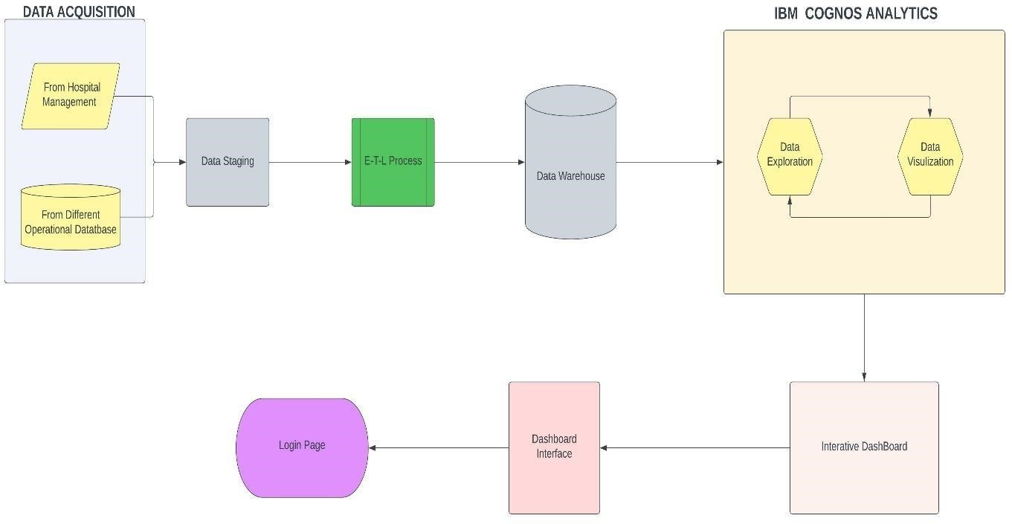

**ETL PROCESS (DATA INTEGRATION PROCESS):**

